Audio-Visual Entrainment: The Application of Audio-Visual Entrainment for the Treatment of Seniors’ Issues

David Siever, Edmonton, Alberta, Canada

Abstract: As the majority of the North American population continues to age, cognitive decline in older adults is becoming an ever-growing concern. With the increase in age comes a decrease in cerebral blood flow, slowing of the brain’s alpha rhythm and increased theta activity. These changes correlate with reduced cognition, spanning memory, problem solving ability, difficulty with language and speech, and locomotion. Chronic stress impairs hippocampal function leading to a host of disorders including Alzheimer’s disease. The left hemisphere of the brain has a tendency to loose functionality before the right side, which may enhance spatial creativity and when coupled with fears and feelings of helplessness, may also bring forth depression. Preliminary studies of Audio-visual entrainment (AVE) have shown this technique to be promising in the treatment of age-related issues common with our senior citizens. AVE is proving to rehabilitate cognitive function in seniors and the best application of AVE may be that as a prophylactic against cognitive decline.

Introduction

Cognitive decline and dementia in aging adults is an ever-growing problem, not only because the numbers of older adults are expanding, but longer life increases the likelihood of loss of memory and decline in cognitive performance (dementia). The Diagnostic and Statistical Manual of Mental Disorders (DSM IV) describes dementia in this basic statement: The essential feature of a dementia is the development of multiple cognitive deficits that include memory impairment and one or more of the following cognitive disturbances: aphasia, (impaired ability to use and comprehend words); apraxia (brain originated difficulty moving parts of the mouth, tongue or lips with impaired speech); agnosia (difficulty recognizing shapes or copying drawings) or a disturbance in executive functioning (logical thinking). The cognitive deficits must be severe enough to cause impairment in occupational or social functioning and must represent a decline from a previously higher level of functioning. (American Psychiatric Association, 1994, p. 134).

Dementia in both the more common ischemic vascular dementia (IVD) and dementia of the Alzheimer’s type (DAT) increase linearly with increasing age (Mohs, et al., 1987; Rocca, et al., 1991) to the point where these dementias have become epidemic within our aging population (Fratiglioni, et al., 1991; Bachman, et al., 1992). Mortel and his colleagues (1994) states, “The pathogenesis of DAT appears to be largely determined and characterized by beta amyloid deposits, neurofibrilliary tangles, and neuritic plaques that impair cortical and sub-cortical synaptic function.” Their study also found that in the IVD population, hypertension and smoking are roughly 1.5 times that of normal, heart disease is double and diabetes is triple that of normal. In the DAT population, hypertension is roughly 2/3 that of normal and heart disease is ½ that of normal. DAT has also been characterized as a “hippocampal dementia” and autopsies have revealed a high correlation of excessive theta brain wave activity with neuronal loss in the hippocampi (Rae-Grant et al, 1987).

Here Cometh the Rain Man

Some of those with autism have brilliant skills known as savant abilities. The skills they possess are the aftermath of left brain damage or dysfunction from fetal testosterone or other damage and are therefore typically confined to right brain functioning, which includes music, math, art and other spatial abilities. Some can play complete concertos after hearing them only once. Others have memorized every name in the phone book or every highway in the USA or draw pictures of amazing detail after just a brief exposure to a scene. Some have brilliant knowledge of sports trivia or license plate numbers. Although these skills are intrinsically tied to a remarkable, specific memory, savants with them lack an understanding of any meaning or reasoning as to what they are doing.

And there may be a little “Rain Man” in all of us because, like autistic savants, as some seniors develop certain types of dementia, they become brilliant with artistic and musical abilities (Treffert & Wallace, 2002; Miller, et al., 1998). Neurons in the left temporal and frontal lobes (frontotemporal dementia) appear to be more delicate than those in the right and often take the “hit” sooner in life, allowing the right hemisphere to take control, and like autistic savants, leave the inflicted with a loss of reasoning ability but heightened artistic and musical ability (Treffert & Wallace, 2002). These seniors paint magnificent drawings or play concertos even though they have never had these abilities before. Unfortunately, as dementia spreads into the right brain, these skills eventually disappear, leaving the person in a withered condition.

Haunted By the Past

The American Psychiatric Association defines psychological trauma as a threat to life, to yourself or someone close to you accompanied by intense fear, horror or helplessness. Psychological trauma affects about half of all Americans sometime in their lives. Every year, in the USA, more than 1 million children are confirmed as victims of child abuse (Teicher, M., 2002). Close to 50 million American adults have been abused in childhood alone, not to mention adult traumas, leaving about 30 million Americans with posttraumatic stress disorder (PTSD), making it one of the most common illnesses in the USA (Bremner, 2002). A full 8% of Americans have a history of PTSD related to a wide variety of incidents including child abuse, assault, rape, car accidents, natural disasters, etc. (Kessler, et al, 1995). There are roughly tenfold more civilian Americans suffering from trauma and PTSD than those with combat trauma in military personnel.

While acute (mild) stress seems to enhance mental function, chronic (severe) stress impairs hippocampal function, which in turn, may lead to multiple sclerosis, anxiety, depression, posttraumatic stress disorder, schizophrenia and Alzheimer's disease (Esch, et al., 2002). Both Vietnam war-vets and women with abuse-related PTSD have reduced blood flow in the hippocampus and medial prefrontal cortex (Bremner, et al, 1999). People with PTSD do not have normal activation of the prefrontal medial cortex and are not able to extinguish their own fear responses while watching a movie involving violence (Bremner, et al., 1997), whereas people without PTSD are able to rationalize that they are only watching a movie and do not show a trauma response to the movie. What this means is that those with PTSD live in an irrational and constant state of fear.

Fear also inflicts continued damage to the frontal and temporal regions, known as frontotemporal dementia (Bremner, 2002). Frontotemporal damage impairs the ability to control fear and the ability to reason and understand the significance of events in their lives (Bremner, 2002), leaving the inflicted in a generalized state of anxiety, fear and confusion. Anxiety and fear increases cortisol in the brain. Cortisol counteracts a brain-nourishing hormone called brain-derived neurotrophic factor or BDNF (Bremner, 2002). Loss of BDNF leads to neuronal cell death within the hippocampus, which impairs memory. As mentioned above, hippocampal loss plays a major role in the development of DAT in which the ability to form memories is impaired. In fact, those inflicted with PTSD often cannot remember what they had for breakfast a few hours before and have extreme difficulty learning new things. Unfortunately, PTSD inflicted dementia can affect persons as young as teenagers and up (Bremner, 2002). Seniors who live in fear suffer early onset dementia.

In relation to fear, a 1996 study by Levy revealed that when seniors were given subconscious cues which activated positive stereotypes of aging, their memory and self-reliance in remembering improved and when they were given negative subconscious cues, their memory and self-reliance in remembering worsened. What most influenced their response however, was the degree of importance that stereotyping was to their self-image – a negative stereotype activated fears within them and impaired their memory and self-reliance in remembering. Those who weren’t concerned about self-image didn’t respond either way.

I’m Falling For You (or anything near the floor) Baby

Falls involving both seniors and children account for approximately 24% of the 147 million emergency room visits logged every year (Burt & Fingerhut, 1998) and with 7 million annual falls involving seniors over the age of 65 years (Jacobson, 2001; Zaida & Alexander, 2001) with costs soaring as high as $12.4 billion annually within the USA (National Safety Council, 1996).

Compared with children, however, seniors are 10 times more likely to be hospitalized and eight times more likely to die as a direct result of their fall (Runge, 1993). In fact, falls are the leading cause of injuries and injury-related deaths among persons aged 65 and older (Fife & Barancik, 1985; Hoyert, et. al., 1999). Falls are the cause of 95% of hip fractures in senior women (Stevens & Olsen, 1999). Hip fractures in turn are associated with decreased mobility, onset of depression (Scaf-Klomp, et al., 2003), diminished quality of life, and premature death (Zuckerman, 1996). Older age, depression, and gait or balance impairments are primary factors for inability to get up after a fall (Colon-Emeric, 2002). In summary, falls involving seniors come at great emotional and financial cost in those communities where an abundance of seniors reside.

Brain Waves and Dementia

The brain generates four basic brain waves: delta, theta, alpha and beta. Beta brain waves are in the frequency range of 13 to 35 Hz. For the purpose of this article we will consider beta activity in the frequency range of approximately 13 to 20 Hz. This beta activity is associated with a focused, analytic, thinking state (Demos, 2005). Beta activity is more prevalent in the frontal regions where higher levels of cognitive thought and reasoning take place.
Theta brain waves are in the 4 to 7 Hz range. Theta activity is associated with creativity and daydreaming, but also with distractibility, inattention and emotional disorders (Demos, 2005). Theta is the primary abnormal brain wave of children with ADHD. Normal theta/beta ratios for children are in the range of 2.5 to 1 and 2 to 1 in adults. Heightened theta/beta ratios are coincident with slow brain wave disorders and associated with foggy thinking, slow reaction times, difficulty with calculations, poor judgment and impulse control (Demos, 2005).

Delta brain waves are primarily related to sleep and therefore make up 40% of all brain wave activity in babies and only 5% of activity in adults. High amplitude, rhythmic delta activity is associated with traumatic brain injury (Demos, 2005).

Many brain wave studies have confirmed a natural slowing of alpha activity with age, which is associated with a shorter life (Nakano, 1992). It has also been shown that an increase in overall theta activity is the best and earliest indicator of cognitive decline (Prichep, et al., 1994).

The Geriatric Deterioration Scale (GDS) is a seven-stage subjective assessment of DAT. Stage 1 represents the best cognitive function while higher stages represent increases in dementia up to Stage 7, which reflects severe DAT. Prichep found a direct and linear correlation between progressive increases in theta and increases in severity of cognitive decline as measured on the GDS from stages 2 through 5. The severest stages of cognitive decline (stages 6 and 7) correlated highly with additional increases in delta, the slowest brain wave rhythm (normally associated with sleep or severe brain damage. The regions in the brain with the highest increases in theta carved a temporoparietal arc across the head.

Cerebral Blood Flow

Cerebral blood flow (CBF) has been shown to decline fairly linearly with age (Hagstadius & Risberg, 1989) and with men having less CBF than women (Gur, et al, 1987
) as shown in Figure 1. Both IVD and DAT groups have roughly 4% less cerebral blood flow (62 ml/100g of brain weight/minute vs 67 ml/100g of brain weight/minute) than controls (Mortel, et al., 1994). Hirsch, et al (1997) in a study of 45 seniors with DAT, found that the majority of blood flow deficits were in both left and right temporoparietal regions. When the left side was affected, language impairments developed and when the right side was affected, there were impairments in praxis (the ability to be proficient in doing normal, habitual activities).

Figure 1. CBF Declining with Age

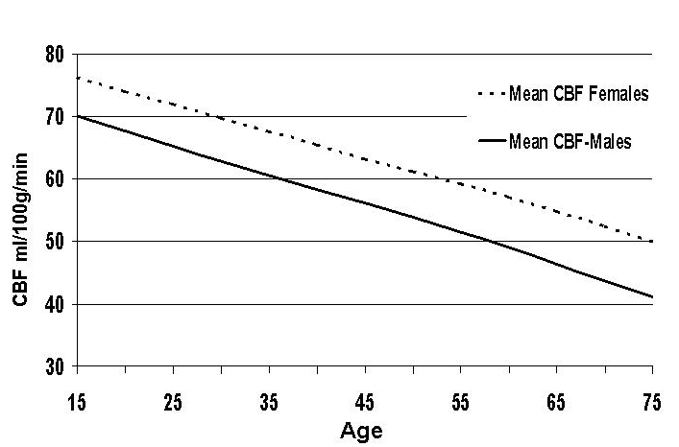

Entrainment and Dementia

Visual entrainment (VE) is affected by dementia. Visual entrainment normally has its greatest impact at the natural alpha frequency, which is typically about 10 Hz (Siever, 2003). Dementia causes a downward skew in the peak brain wave frequency, which in turn also causes a slowed frequency response to VE (Politoff, et al., 1992). However, despite this downward shift, VE nonetheless, affects a wide range of brain wave activity (Politoff, et al., 1992), making it a viable method for reducing aberrant dementia related brain wave activity.

VE also produces increases in cerebral blood flow, which would seem to be beneficial since dementia involves a reduction in cerebral blood flow. Figure 2 shows the impact of VE on cerebral blood flow in response to various frequencies (Fox & Raichle, 1985).

Figure 2
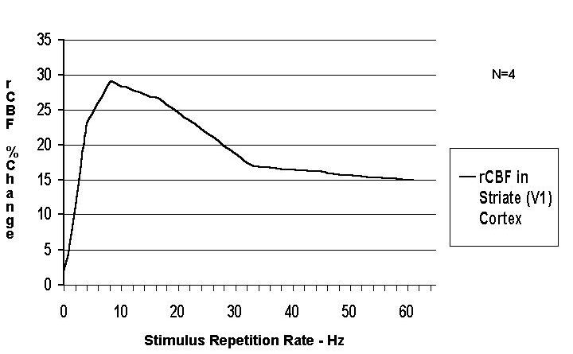

Studies Utilizing Audio-Visual Entrainment (AVE) for

Improving Cognitive Ability and Balance

One of the first studies utilizing AVE for improving cognition in a senior was by Tom Budzynski (1998), where he used both neurofeedback and AVE to improve mental function in a 75-year-old man. In a further study using a DAVID Paradise XL and a 10-station multiple system, Budzynski & Tang (2001) treated 31 seniors from two seniors’ homes in Seattle. They used audio-visual stimulation (AVS) “sessions” in the form of random frequency stimulation from 9 to 22 Hz over an average of 33 treatments to rejuvenate brain function. Because 10 people were treated at a time, treatment was very cost effective as compared with one-on-one therapy such as cognitive rehabilitation or neurofeedback. A computer based continuous performance test (CPT), the Microcog, was used to assess mental function (Elwood, 2001).

The Microcog measures attention, reasoning ability, memory, spatial ability, reaction times, processing speed and accuracy, cognition and proficiency. Approximately 60 to 70% of all subjects (Figure 3) showed improvements in these measures. Figure 4 shows the average group improvements in different measures within the Microcog.

Figure 3. Microcog Results Following AVE - % of Seniors with Improvement.
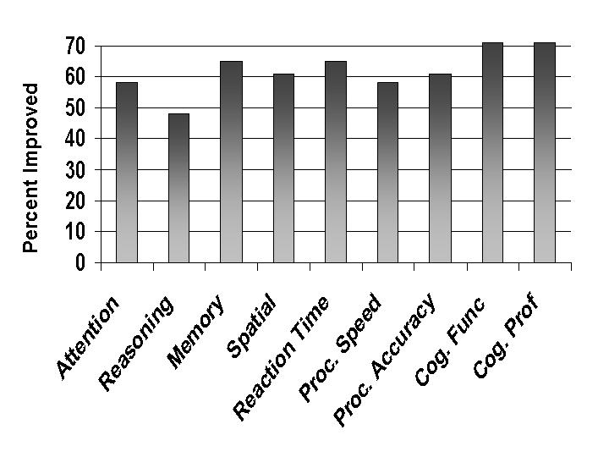

Figure 4. Microcog Results Following AVE – Amount of Improvement.

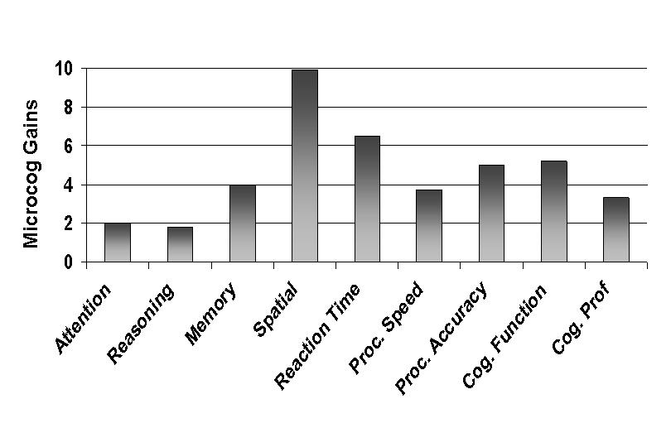

Within the group was one woman with rapidly progressing dementia of the Alzheimer’s type. Because of the severity of her dementia, a full quantitative electroencephalogram (QEEG) and Low Resolution Brain Electromagnetic Tomography (LORETA) assessment was performed. The LORETA is a technique which provides a three dimensional view into the subcortical structures of the brain (Pascual-Marqui, 2002). According to the LORETA, the AVS appeared to produce improvement in various brain regions that are involved in the progression of DAT. The results appeared during the first AVS stimulation period and lasted through the continuation of the 33-session treatment period. Specifically, the LORETA showed decreases in abnormal delta in the left temporal lobe and in the superior temporal gyrus and continued beyond the 30-session treatment. In other words, AVS halted the progression of her DAT and reversed its effects to some degree. This is the first evidence that AVS and perhaps AVE could be used as a prophylactic against age-related dementia.

Seniors and Locomotion

Interventions to reduce the risk of falling by reducing depressive symptoms have been only partly successful among the elderly living in the community. Successful studies have used multifaceted approaches including exercise programs, home modifications, falls-prevention education, improving vision and hearing, alcohol abuse awareness, and wearing safer footwear (Rubenstein et al., 1990; Steinberg et al., 2000; Tinetti et al., 1994). However, a perceived problem with interpreting the findings of multifactorial interventions is that determining which component of the intervention program was more effective in reducing depressive symptoms is not always possible (Cumming, 2002). This is a particular concern for public health professionals who want to plan cost-effectiveness fall-prevention strategies for whole populations of elderly persons.

The focus of this present study is to develop a single intervention. Particularly one that will decrease depressive symptoms and reduce falls in the elderly living in the community. This intervention, which involves entraining brain waves, is commonly known as audio-visual entrainment (AVE). AVE differs from AVS in that AVE involves stimulation for several minutes of a non-changing or only slightly changing frequency whereas AVS employs fairly random frequencies. The frequency of stimulation when using AVE is clearly visible in the EEG of the brain of the person who is receiving the stimulation whereas AVS is not.

Evidence in the literature demonstrates a link between AVE and the reduction of depression (Kumano, et al, 1996; Berg & Siever, 2000). However, the precise relationship between AVE and falling remains unclear. It is plausible that a cognitively intact older person who falls or almost falls could reduce his/her chances of future falls by improving his/her precipitating depressive symptoms. The most common origin of depression is related to hypoactivation of the left frontal lobe function (Rosenfeld, 1997; Davidson, et al., 1999), which is observed as heightened alpha activity. This heightened left alpha creates an alpha asymmetry between the left and right frontal lobes, often leaving the right side hyperactivated with the outcome being anxiety (Davidson, et al., 1999). It is plausible that AVE administered in such a way that inhibits left frontal lobe alpha will improve cognition simultaneously while reducing depression and anxiety. In this study, that is exactly what was done (anxiety, however, wasn’t measured).

The study involving 80 randomly assigned seniors by Berg & Siever (2004), shown in Figures 12 and 13, utilized a stimulus of 17 to19 Hz in the right visual fields and right headphone (left brain stimulation) and provided a stimulus at 10 Hz in the left visual fields and left headphone (right brain stimulation) during a 30-minute preprogrammed session. This approach normalized the asymmetry in brain “alpha” activity that is typical of depression (Rosenfeld, 1997). As a result, depression recorded on the Geriatric Depression Scale (GDS) was reduced significantly (Figure 5).

Figure 5. Geriatric Depression Scale

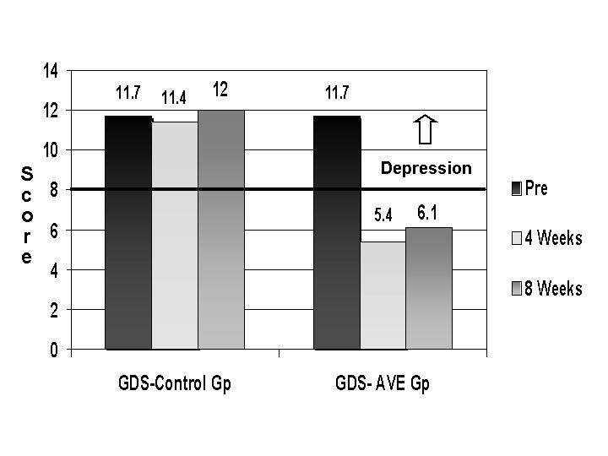

Balance and gait were measured using the Tinetti Assessment Tool (Tinetti, 1986). Figure 6 shows the improvement in balance as seen on the Balance Mean Scores (BMS). As depression lifted, balance improved.

Figure 6. Balance Mean Scores

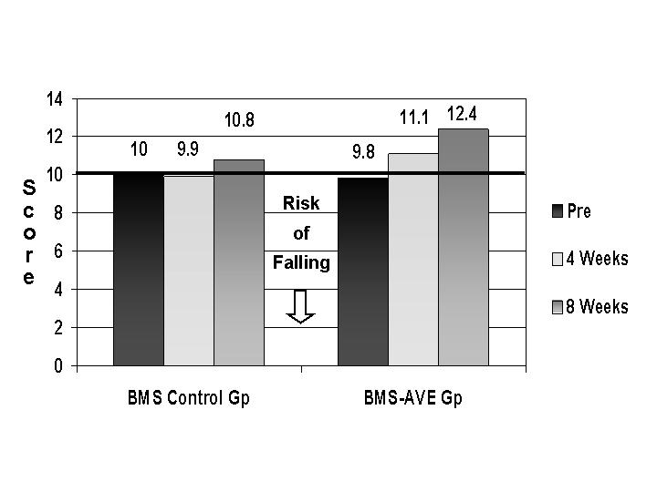

In the first month balance improved considerably (P=0.0055), which is seen as a negative correlation (Figure 7). Gait, however, didn’t improve within the first four weeks (p=0.112). Gait, however, did improve once the fear of falling was reduced and confidence was restored. About four weeks on average was required before the participants trusted themselves enough to begin walking with a straighter gait. Their gait continued to improve throughout the eight weeks (p=0.0001).

Figure 7. Correlation of Balance & Gait in Relation to Initial Depression Scores
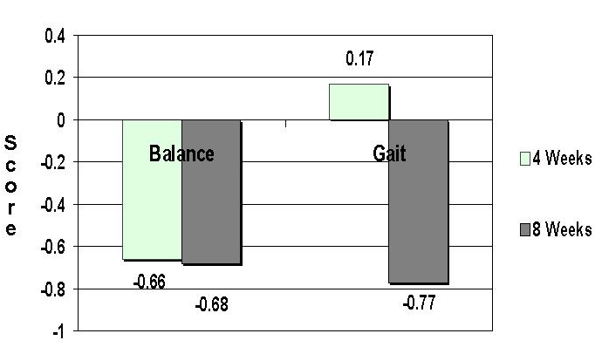

Conclusion

AVS has a fairly significant impact on cognitive function, as shown on the Microcog. AVE applying beta frequency stimulation to the left hemisphere of the brain and alpha frequency to the right hemisphere of the brain had a very significant impact at reducing depression while also simultaneously reducing the risk of falling by improving balance and gait.

Address all correspondence to David Siever at Mind Alive Inc. Toll Free: 1-800-661-MIND (6463), Ph: 780-450-3729. Address: 9008-51 Avenue, Edmonton, Alberta, Canada, T6E 5X4. Web: www.mindalive.com Email: info@mindalive.com
Microcog. Harcourt Assessment Inc. San Antonio, TX. USA. Ph: 800-211-8378. Website: www.harcourtassessment.com. References American Psychiatric Association, Diagnostic and Statistical Manual of Mental Disorders, Fourth Edition, P. 134. Washington, D.C. Bachman, D., Wolf, P., Linn, R., Knoefel, J. E., Cobb, J., Belanger, A., D'Agostino, R. B., & White, L. R. (1992). Prevalence of dementia and probable senile dementia of the Alzheimer type in the Framingham study. Neurology, 42, 115-119. Berg, K. & Siever, D. (2000). Audio-visual entrainment as a treatment modality for seasonal affective disorder. Presentation at AAPB 31st Annual Meeting. Denver, CO. Berg, K. & Siever, D. (2004). The effect of audio-visual entrainment in depressed community-dwelling senior citizens who fall. In-house manuscript. Mind Alive Inc., Edmonton, AB, Canada. Bremner, J., Innis, R., Ng, C., Staib, L., Duncan, J., Bronen, R., Zubal, G., Rich, D., Krystal, J., Dey, H., Soufer, R., Charnet, D. (1997). PET measurement of central metabolic correlates of yohimbine administration in posttraumatic stress disorder. Journal of Traumatic Stress, 10, 37-50. Bremner, J., Narayan, M., Staib, L., Southwick, S., McGlashan, T., Charney, D. (1999). Neural correlates of memories of childhood sexual abuse in women with and without posttraumatic stress disorder. American Journal of Psychiatry, 156, 1787-1795. Bremner, D. (2002). Does Stress Damage the Brain? W.W. Norton & Company: New York, NY. Budzynski, T. & Budzynski, H. (2001). Brain brightening – preliminary report, December 2001. in house manuscript. Mind Alive Inc. Edmonton, Alberta, Canada. Budzinski, T., Budzinski, H., & Sherlin, L. (2002). Short and long term effects of audio visual stimulation (AVS) on an Alzheimer's patient as documented by quantitative electroencephalography (QEEG) and low resolution electromagnetic brain tomography (LORETA) [Abstract]. Journal of Neurotherapy. Vol 6,1. Burt, C. & Fingerhut, L. (1998). Injury visits to hospital emergency departments: United States, 1992-1995. Vital Health Statistics, 13, 1-76. Colon-Emeric, C. (2002). Falls in older adults: assessment and intervention in primary care. Hospital Physician, April, 55-66. Cumming, R. G. (2002). Intervention strategies and risk-factor modification for falls prevention: a review of recent intervention studies. Clinics and Geriatric Medicine, 18, 175-189. Davidson, R., Abercrombie, H., Nitschke, J., & Putnam, K. (1999). Regional brain function, emotion and disorders of emotion. Current Opinion in Neurobiology, 9, 228-234. Demos, J. (2004). Getting Started With Neurofeedback. 112-119. New York: W.W. Norton & Company. Elwood, R. W. (2001). MicroCog: assessment of cognitive functioning. Neuropsychology Review, 11(2), 89-100 Esch, T., Stefano, G., Fricchione, G., & Benson, H. (2002). The role of stress in neurodegenerative diseases and mental disorders. Neuroendocrinology Letters, 23, 199-208. Fife, D., & Barancik, J. I. (1985). Northeastern Ohio trauma study, 3: incidence of fractures. Annual Emergency Medicine, 14, 244-248. Fox, P. & Raichle, M. (1985). Stimulus rate determines regional blood flow in striate cortex. Annals of Neurology, 17, (3), 303-305. Fraglioni, L., Grut, M., Forsell, Y., Viitanen, M., Grafstrom, M., Holmen, K., Ericsson, K., Backman, L., Ahlbom, A., & Winblad, B. (1991). Prevalence of Alzheimer’s disease and other dementias in an elderly urban population: relationship with age, sex, and education. Neurology, 41, 1886-1892. Gur, R. C., Gur, R. E., Obrist, W., Skolnick, B., & Reivich, M. (1987). Age and regional blood flow at rest and during cognitive activity. Archives of General Psychiatry, 44, 617-621. Hagstadius, S. & Risberg, J. (1989). Regional cerebral blood flow characteristics and variations with age in resting normal subjects. Brain and Cognition, 10, 28-43. Hirsch, C., Bartenstein, P., Minoshima, S., Willoch, F., Buch, K., Schad, D., Schwaiger, M., & Kurk, A. (1997). Reduction of regional cerebral blood flow and cognitive impairment in patients with Alzheimer’s disease: evaluation of an observer independent analytic approach. Dementia and Geriatric Cognitive Disorders, 8, 98-104. Hoyert, D.L., Kochanek, K.D., & Murphy, S.L. (1999). Deaths: final data for 1997. National Vital Statistics Report 1999, 47, 1-104. Jacobson, G. (2001). Assessing the risk of falls in the elderly: above and beyond the ENG. Journal of Hearing, 54 (6), 10-14. Kessler, R., Sonnega, A., Bromet, E., Hughes, M., & Nelson, C. (1995). Posttraumatic stress disorder in the national comorbidity survey. Archives of General Psychiatry, 52, 1048-1060. Kumano, H. l., Horie, H., Shidara, T., Kuboki, T., Suematsu, H., & Kindschi, C. L. (1996). Treatment of depressive disorder patient with EEG-driven photic stimulation. Biofeedback and Self-Regulation, 21, 323-334. Levy, B. (1996). Improving memory in old age through implicit self-stereotyping. Journal of Personality and Social Psychology, 71, (6), 1092-1107. Miller, B. L., Cummings, J., Mishkin, F., Boone, K., Prince, F., Ponton, M., Cotman, C. (1998). Emergence of artistic talent in frontotemporal dementia. Neurology, 51, 4, 978-982. Mohs, R. C., Breitner, J. C., Silverman, J.M., & Davis, K. L. (1987). Alzheimer’s disease. Morbid risk among first-degree relatives approximates 50% by 90 years of age. Archives of General Psychiatry, 44, 405-408. Mortel, K., Pavol, A., Wood, S., Meyer, J., Terayama, Y., Rexer, J., & Herod, B. (1994). Perspective studies of cerebral perfusion and cognitive testing among elderly normal volunteers and patients with ischemic vascular dementia and Alzheimer’s disease. Journal of Vascular Diseases, 45, 171-180. Nakano, T., Miyasaka, M., Ohtaka, T., & Ohmori, K. (1992). Longitudinal changes in computerized EEG and mental function of the aged: a nine-year follow-up study. International Psychogeriatrics, 4, (1), 9-22. National Safety Council. (1996). Accident facts. Itasca (IL): National Safety Council. Pascual-Marqui, R. D. (2002). Standardized low resolution electromagnetic tomography (sLORETA): technical details. Methods & Findings in Experimental & Clinical Pharmacology, 24, 5-12. Politoff, A. L., Monson, N., Hass, P., & Stadter, R. (1992). Decreased alpha bandwidth responsiveness to photic driving in Alzheimer’s disease. Electroencephalography and Clinical Neurophysiology, 82(1), 45-52. Prichep, L., John, E., Ferris, S., Reisberg, B., Almas, M., Alper, K., & Cancro, R. (1994). Quantitative EEG correlates of cognitive deterioration in the elderly. Neurobiology of Aging, 15 (1), 85-90. Rae-Grant, A., Blume, W., Lau, C., Hachinski, V., Fisman, M., & Merskey, H. (1987). The electroencephalogram in Alzheimer-type dementia: A sequential study correlating the electroencephalogram with psychometric and quantitative pathologic data. Archives of Neurology, 44, 50-54. Rocca, W. A., Hofman, A., Brayne, C., Breteler, M. M. B., Clarke, M., Copeland, J. R. M., Dartigues, J. F., Engedal, K., Hagnell, O., Heeren, T. J., Jonker, C., Lindesay, J., Lobo, A., Mann, A. H., Mölsä, P. K., Morgan, K., O'Connor, D. W., da Silva Droux, A., Sulkava, R., Kay, D. W. K., & Amaducci, L. (1991). Frequency and distribution of Alzheimer’s disease in Europe: a collaborative study of 1980-1990 prevalence findings. Annals of Neurology, 30, 381-90. Rosenfeld, P. (1997). EEG biofeedback of frontal alpha asymmetry in affective disorders. Biofeedback, 25 (1), 8-12. Rubenstein, L. Z., Robbins, A. S., Josephson, K. S., Schulman, B.L., & Osterweil, D. (1990). The value of assessing falls in the elderly population: a randomized clinical trial. Annual of Internal Medicine, 113, 308-316. Runge, J. (1993). The cost of injury. Emergency Medical Clinics of North America, 11, 241-253. Scaf-Klomp, W., Sanderman, R., Ormel, J., & Kempen, G. (2003). Depression in older persons after fall-related injuries: a prospective study. Age and Aging, 32: 88-94. Siever, D. (2003). Audio-visual entrainment: 1. History and physiological mechanisms. Biofeedback. 31 (2), 21-27. Stevens J. & Olson, S. (1999). Reducing falls and resulting hip fractures among older women. Home Care Provider; 5:134-141. Teicher, M. (2002). Scars that won’t heal: the neurobiology of child abuse. Scientific American, 286(3), 68-75. Tinetti, M. F. (1986). Performance-oriented assessment of mobility problems in elderly patients. Journal of American Geriatric Society, 34, 119-126. Treffert, D. & Wallace, G. (2002). Islands of genius. Artistic brilliance and a dazzling memory can sometimes accompany autism and other developmental disorders. Scientific American, 286(6), 76-85. Zaida, D. & Alexander, M. (2001). Falls in the elderly: identifying and managing peripheral neuropathy. Nurse Practitioners, 26, 86-88. Zuckerman, J. D. (1996). Hip fracture. New England Journal of Medicine. 334,1519-1525.

